README

Monday, October 16, 2017

This document describes the data gathering for a Universal Robot (UR) that supplies a socket interface. Multiple adapters to UR robots are possible, each contained within one MTConnect Agent.

This document presents a brief background on the mechanics of the MTConnect agent for the UR robots. This document assumes the reader is familiar with MTConnect operation, and for deeper explanation of MTConnect, please refer to MTConnect URL: <http://www.mtconnect.org/> for more information. This document concerns itself with how an embedded Adapter operates. One or more embedded adapters read a configuration file, and then reads real-time data from a UR robot using the established UR TCP protocol.

# Background

MTConnect is a new standard developed to facilitate the exchange of data on the manufacturing floor. The MTConnect open specification provides for cost effective data acquisition on the manufacturing floor for machine tools and related devices. MTConnect is based upon prevalent Web technology including XML and HTTP. Figure 1 shows the MT Connect architecture. An “MTConnect Device” is a piece of equipment – in this case a NIKON CMM machine tool, which (optionally) includes an MTConnect Adapter so that we can get data from it. The “Agent” is a process that acts as a “bridge” between a device and a factory “Client Application”. To learn more about MTConnect visit: <http://www.mtconnect.org/>

Figure 1 shows a typical MTConnect UR Robot system architecture (with one or more UR robot devices). Communication between a Windows PCs and the UR CNC is assumed, communicating over Ethernet to communicate the UR robot status.



Figure MTConnect NIKON CMM Logging Agent system architecture

This document describes the communication and data gathering software technology used to communicate with a UR robot and provides data for an MTConnect Agent to make available using a web broswer. Multiple adapters to UR robots software are possible, each contained within one MTConnect Agent.



Figure Universal Robots - UR3, UR5, and UR10

The UR Agent contains back end adapters that communicate with the UR controller via a TCP socket. UR supplies three interfaces: primary, secondary and real-time. The secondary communication channel was used to retrieve robot status at 15Hz.

The UR robot communicates a lot of information. If you bring up a browser and enter the IP plus port 5000 and the command current, e.g., <http://xxx.xxx.xxx.xxx:5000/current> the agent will return the current state of the data items in the UR robot. Below a VB script that extracts the MTConnect agent XMl and formats it into a table is shown:

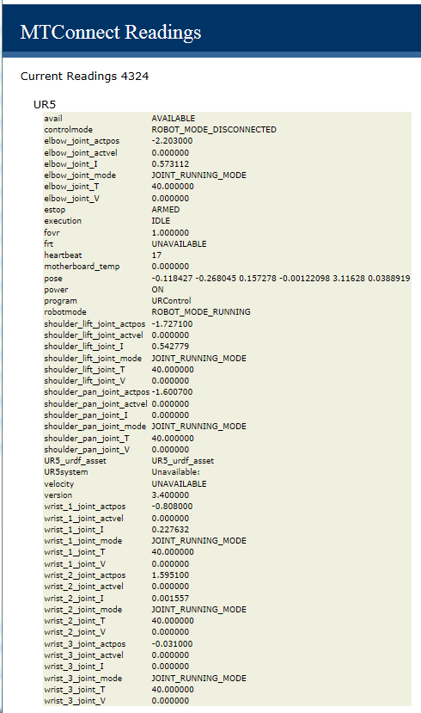

Figure Web-browswer Table Display of MTConnect Agent Data Items

These log fields, specifically the field 5 “status” offers sufficient information to develop a stack lite state model. Below is the translation of the Nikon status messages into MTConnect controller logic:

|  |  |
| --- | --- |
| State | Action |
|  | power=ON  controllermode=MANUAL  execution=IDLE |
|  | power=OFF  controllermode=UNAVAILABLE  execution= UNAVAILABLE |
|  | power=ON  controllermode=AUTOMATIC  execution=EXECUTING |
|  | power=ON  controllermode=MANUAL  execution=IDLE |
|  | power=ON  controllermode=MANUAL  execution=IDLE  error=message following dash |
|  | power=ON  controllermode=MANUAL  execution=IDLE  program=message following dash |
|  | RPM and xyz move if automatic and executing |
|  |  |

Because of the deficiency of the MTConnect state logic, some side effects are generated to make the controller appear to be operating: positions for x,y,z and RPM change after every update if the controller is in automatic mode and executing.

# UR Robot URDF Information from MTConnect Agent

ROS uses URDF as a general-purpose robot model, which includes the kinematic as well as other robot specification information. The URDF specification covers the kinematic and dynamic description of the robot, the visual representation of the robot, and the collision model of the robot. URDF assumes the robot consists of rigid links connected by joints; flexible elements are not supported. URDF can be used to model a kinematic chain or kinematic tree robot.

But since URDF is an XML specification, URDF is limited to robots that exhibit only tree structures representations, ruling out all parallel robots like Stewart Platforms.

Most Industrial Robots are kinematic chain robots and so can be modeled as a serial set of links and joints. Multi-arm robots can be also be modeled in URDF as a kinematic tree of links connected to multiple joints, such as a headed robot with two arms. The Unified Robot Description Format (URDF) is an XML specification to describe a robot. Because it is an XML specification, the information is modeled as a tree with elements (e.g., "<Name>'') with subelement branches under elements. Each robot is modeled in ROS by an URDF file, which contains

**Link Information** Link elements describe a rigid body with an geometry, inertia, visual features, obstacle bounds and other robot properties. The visual element within the link element contains the specification for display of the link in RVIZ (either a mesh or a geometry element). The visual also contains the material element which sets the color of

the link.

**Joint Information** Joint elements describe the kinematics and dynamics of the joint and also specify the safety limits of the joint. Joint elements contain elements for parent link, child link, axis of rotation, calibration, dynamics, limit, and safety controller information. Joints are also able to mimic other joints. URDF assumes each joint is either a revolute, prismatic, fixed, or continuous type joint which depending on the type can have position, velocity and effort limits specified.

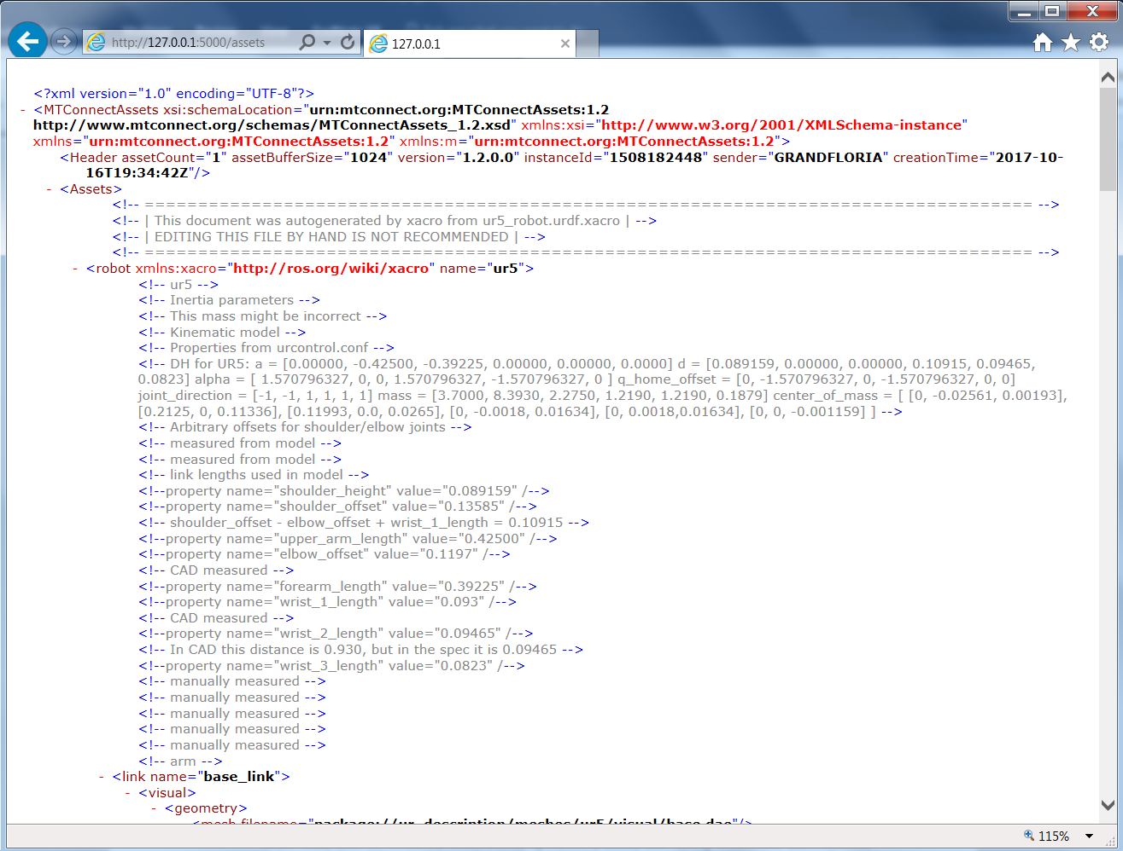

Figure URDF for UR5 Robot as MTConnect Asset

# Version Information from MTConnect Agent

The version information of the various MTConnect components is available through web browser access. It is recommended to use Google Chrome as it understand the XSLT formatting of the XML (Internet Explorer is baffled.)

The open source core MTConnect agent is downloaded from github and “frozen”. The version used is:

MTConnect Agent Version 1.2.0.0 - built on Sat Oct 12 13:30:24 2013

It is not perfect but the output shown below gives an indication of the software involved in the MTConnect Agent operation. It can be modified to include other version information, but requires a recompilation at this time.

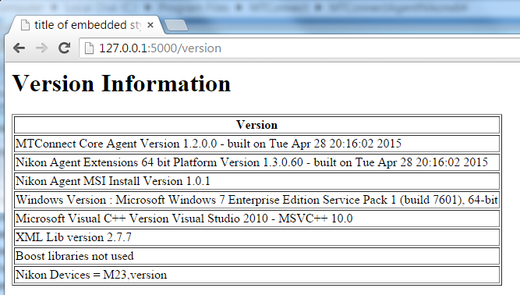

# Configuration

The Nikon MTConnect Agent uses the open-source MTconnect agent version 1.2 as the backbone to read http requests, generate XML responses, and update the underlying data. There is a NIST log file adapter addition to remotely read local or remote windows UNC files and then parse. The adapter can handle multiple device log file and update the core MTConnect agent.

The configuration is done at installation time during the wizard screens. The user must supply pairs of device names and UNC log file name, e.g., camio1,\\servername\C$\Program Files\Nikon\logfile.log From Wikipedia: The Microsoft Windows UNC, short for Universal Naming Convention or Uniform Naming Convention, specifies a common syntax to describe the location of a network resource, such as a shared file, directory, or printer. The UNC syntax for Windows systems has the generic form:

\\ComputerName\SharedFolder\Resource

Microsoft often refers to this as a "network path". You can use local paths, but if you are doing remote access of the log file, you must use the UNC convention.

The user can modify the config.ini file in the C:/Program Files/MTConnect/MTConnectAgentNikonx64 folder. However, the devices.xml and the agent.cfg files necessary for the core MTConnect agent are generated at installation time, and thus a reinstallation would be required to modify these files.

In the config.ini file, you can change the ServiceName, Agent port and query times of the log files. These changes will take if you stop/restart the Agent service or reboot the machine.

[GLOBALS]

ServiceName=NikonAgent

AgentPort=5000

QueryServer=10000

ServerRate=5000

Debug=0

ResetAtMidnite=false

MTConnectDevice=camio1

logging_level=FATAL

[camio1]

ProductionLog=\\servername\c

Thus, the agent it reads the config.ini file for list of “MTConnectDevice”s under the Globals section. The configuration file also sets the Global flags: QueryServer, ServerRate, Debug, AgentPort(default 5000), and ResetAtMidnite.

## Struct Decoder

The struct_decoder peforms conversions between network byte arrays and C++ struts. This intended for use in handling binary data from network connections. First, all the structure variables are declared. Then, preprocessor macros are used to define the size and order of the byte stream associated with this C++ struct. It relies on sizeof to determine the size of the struct variable, and uses a printf specifier to format the variable for output. It assumes the struct is packed with no padding between variable elements. However, C++ compiler methods can be used to ensure that the variables are slotted with their native size and no padding is performed. (FIXME: show example.)

The struct_decoder struct is useful for reading/writing network byte streams. It uses the preprocessor definition to define a property table describing each entry so they can easily be read/write/print including byte swapping if required. Uses the Curiously recurring template pattern to handle accessing the outermost property

| **Format** | **C Type** | **Standard size**  **bytes** | **Notes** |
| --- | --- | --- | --- |
| %c | **Signed char** | 1 |  |
| %c | **unsigned char** | 1 | (3) |
| %uc | **unsigned char** | 1 | (3) |
| %c | **bool** | 1 | (1) |
| %u | **short** | 2 | (3) |
| %hu | **unsigned short** | 2 | (3) |
| %d | **int** | 4 | (3) |
| %ud | **unsigned int** | 4 | (3) |
| %ld | **long** | 4 | (3) |
| %uld | **unsigned long** | 4 | (3) |
| %lld | **long long** | 8 | (2), (3) |
| %ulld | **unsigned long long** | 8 | (2), (3) |
| %f | **float** | 4 | (4) |
| %lf | **double** | 8 | (4) |
| %Lf | **long double** | 16 |  |
| %s | **char[]** |  |  |

Notes:

1. The '?' conversion code corresponds to the **_Bool** type defined by C99. If this type is not available, it is simulated using a **char**. In standard mode, it is always represented by one byte.

*New in version 2.6.*

1. The 'q' and 'Q' conversion codes are available in native mode only if the platform C compiler supports C **long long**, or, on Windows, **__int64**. They are always available in standard modes.

*New in version 2.2.*

1. When attempting to pack a non-integer using any of the integer conversion codes, if the non-integer has a [**__index__()**](https://docs.python.org/2/reference/datamodel.html#object.__index__) method then that method is called to convert the argument to an integer before packing. If no [**__index__()**](https://docs.python.org/2/reference/datamodel.html#object.__index__) method exists, or the call to [**__index__()**](https://docs.python.org/2/reference/datamodel.html#object.__index__) raises **[TypeError](https://docs.python.org/2/library/exceptions.html" \l "exceptions.TypeError" \o "exceptions.TypeError)**, then the [**__int__()**](https://docs.python.org/2/reference/datamodel.html#object.__int__) method is tried. However, the use of [**__int__()**](https://docs.python.org/2/reference/datamodel.html#object.__int__) is deprecated, and will raise **[DeprecationWarning](https://docs.python.org/2/library/exceptions.html" \l "exceptions.DeprecationWarning" \o "exceptions.DeprecationWarning)**.

*Changed in version 2.7:*Use of the [**__index__()**](https://docs.python.org/2/reference/datamodel.html#object.__index__) method for non-integers is new in 2.7.

*Changed in version 2.7:*Prior to version 2.7, not all integer conversion codes would use the [**__int__()**](https://docs.python.org/2/reference/datamodel.html#object.__int__) method to convert, and **[DeprecationWarning](https://docs.python.org/2/library/exceptions.html" \l "exceptions.DeprecationWarning" \o "exceptions.DeprecationWarning)** was raised only for float arguments.

1. For the 'f' and 'd' conversion codes, the packed representation uses the IEEE 754 binary32 (for 'f') or binary64 (for 'd') format, regardless of the floating-point format used by the platform.
2. The 'P' format character is only available for the native byte ordering (selected as the default or with the '@' byte order character). The byte order character '=' chooses to use little- or big-endian ordering based on the host system. The struct module does not interpret this as native ordering, so the 'P' format is not available.

# UR Version of Interfaces Table Comparison

The UR communication interface has several incarnations for different versions. This can be confusing. There is a breakdown of each interface in Excel Spreadsheet format supplied by Universal Robots. Instad of scanning across worksheets, the following table attempts to collate each INPUT interface into a table with changes noted between versions.

Foremost is the robot mode interface which supplies the current operating state of the robot:

|  |  |  |  |  |  |  |  |  |
| --- | --- | --- | --- | --- | --- | --- | --- | --- |
| Interface | 1.6 | 1.7 | 1.8 | 3.0 | 3.1 | 3.2 | 3.3 | 3.4 |
| Robot  Mode  Data | int packageSize  unsigned char packageType  uint64_t timestamp  bool isRobotConnected  bool isRealRobotEnabled  bool isPowerOnRobot  bool isEmergencyStopped  bool isSecurityStopped  bool isProgramRunning  bool isProgramPaused  unsigned char robotMode  double speedFraction | ibid | ibid | int packageSize  unsigned char packageType  uint64_t timestamp  bool isRobotConnected  bool isRealRobotEnabled  bool isPowerOnRobot  bool isEmergencyStopped  bool isProtectiveStopped  bool isProgramRunning  bool isProgramPaused  unsigned char robotMode  unsigned char controlMode  double targetSpeedFraction  double speedScaling | ibid | int packageSize  unsigned char packageType  uint64_t timestamp  bool isRobotConnected  bool isRealRobotEnabled  bool isPowerOnRobot  bool isEmergencyStopped  bool isProtectiveStopped  bool isProgramRunning  bool isProgramPaused  unsigned char robotMode  unsigned char controlMode  double targetSpeedFraction  double speedScaling  double targetSpeedFractionLimit | ibid | ibid |

|  |  |  |  |  |  |  |  |  |
| --- | --- | --- | --- | --- | --- | --- | --- | --- |
| Interface | 1.6 | 1.7 | 1.8 | 3.0 | 3.1 | 3.2 | 3.3 | 3.4 |
| Joint  data | double q_actual  double q_target  double qd_actual  float I_actual  float V_actual  float T_motor  float T_micro  unsigned char jointMode | ibid | ibid | ibid | ibid | ibid | ibid | ibid |

|  |  |  |  |  |  |  |  |  |
| --- | --- | --- | --- | --- | --- | --- | --- | --- |
| Interface | 1.6 | 1.7 | 1.8 | 3.0 | 3.1 | 3.2 | 3.3 | 3.4 |
| Cartesian  Info | double X  double Y  double Z  double Rx  double Ry  double Rz |  |  |  | double X  double Y  double Z  double Rx  double Ry  double Rz  double TCPOffsetX  double TCPOffsetY  double TCPOffsetZ  double TCPOffsetRx  double TCPOffsetRy  double TCPOffsetRz |  |  |  |

|  |  |  |  |  |  |  |  |  |
| --- | --- | --- | --- | --- | --- | --- | --- | --- |
| Interface | 1.6 | 1.7 | 1.8 | 3.0 | 3.1 | 3.2 | 3.3 | 3.4 |
| Version Message | uint64_t timestamp  char source  char robotMessageType  char projectNameSize  char array projectName  unsigned char majorVersion  unsigned char minorVersion  int svnRevision  char array buildDate | ibid | ibid | ibid | ibid | ibid | uint64_t timestamp  char source  char robotMessageType  char projectNameSize  char array projectName  unsigned char majorVersion  unsigned char minorVersion  int bugfixVersion  int buildNumber  char array buildDate |  |

|  |  |  |  |  |  |  |  |  |
| --- | --- | --- | --- | --- | --- | --- | --- | --- |
| Interface | 1.6 | 1.7 | 1.8 | 3.0 | 3.1 | 3.2 | 3.3 | 3.4 |
| Masterboard  Data | int packageSize  unsigned char packageType  short digitalInputBits  short digitalOutputBits  char analogInputRange0  char analogInputRange1  double analogInput0  double analogInput1  char analogOutputDomain0  char analogOutputDomain1  double analogOutput0  double analogOutput1  float masterBoardTemperature  float robotVoltage48V  float robotCurrent  float masterIOCurrent  unsigned char masterSaftyState  unsigned char masterOnOffState  char euromap67InterfaceInstalled  int euromapInputBits  int euromapOutputBits  short euromapVoltage  short euromapCurrent) |  |  | int packageSize  unsigned char packageType  int digitalInputBits  int digitalOutputBits  char analogInputRange0  char analogInputRange1  double analogInput0  double analogInput1  char analogOutputDomain0  char analogOutputDomain1  double analogOutput0  double analogOutput1  float masterBoardTemperature  float robotVoltage48V  float robotCurrent  float masterIOCurrent  unsigned char safetyMode  unsigned char InReducedMode  char euromap67InterfaceInstalled  int euromapInputBits  int euromapOutputBits  float euromapVoltage  float euromapCurrent)  uint32_t (Used by Universal  Robots software only) |  | int packageSize  unsigned char packageType  int digitalInputBits  int digitalOutputBits  char analogInputRange0  char analogInputRange1  double analogInput0  double analogInput1  char analogOutputDomain0  char analogOutputDomain1  double analogOutput0  double analogOutput1  float masterBoardTemperature  float robotVoltage48V  float robotCurrent  float masterIOCurrent  unsigned char safetyMode  unsigned char InReducedMode  char euromap67InterfaceInstalled  int euromapInputBits  int euromapOutputBits  float euromapVoltage  float euromapCurrent)  uint32_t (Used by Universal  Robots software only)  uint8_t operationalModeSelectorInput  uint8_t threePositionEnablingDeviceInput |  |  |

|  |  |  |  |  |  |  |  |  |
| --- | --- | --- | --- | --- | --- | --- | --- | --- |
| Interface | 1.6 | 1.7 | 1.8 | 3.0 | 3.1 | 3.2 | 3.3 | 3.4 |
| Tool  Data | NA | char analogInputRange2  char analogInputRange3  double analogInput2  double analogInput3  float toolVoltage48V  unsigned char toolOutputVoltage  float toolCurrent  float toolTemperature  unsigned char toolMode | ibid | ibid | ibid | ibid | ibid | ibid |

In the configuration data it is sometimes unclear how many fields a "for each joint:" pertains to.

|  |  |  |  |  |  |  |  |  |
| --- | --- | --- | --- | --- | --- | --- | --- | --- |
| Interface | 1.6 | 1.7 | 1.8 | 3.0 | 3.1 | 3.2 | 3.3 | 3.4 |
| Configuration  Data | NA | NA | for each joint:  double jointMinLimit  double jointMaxLimitt  for each joint:  double jointMaxSpeed  double jointMaxAcceleration  double vJointDefault  double aJointDefault  double vToolDefault  double aToolDefault  double eqRadius  for each joint:  double DHa  for each joint:  double DHd  for each joint:  double DHalpha  for each joint:  double DHtheta  int masterboardVersion  int controllerBoxType  int robotType  int robotSubType  for each joint:  int motorType | for each joint:  double jointMinLimit  double jointMaxLimitt  for each joint:  double jointMaxSpeed  double jointMaxAcceleration  double vJointDefault  double aJointDefault  double vToolDefault  double aToolDefault  double eqRadius  for each joint:  double DHa  for each joint:  double DHd  for each joint:  double DHalpha  for each joint:  double DHtheta  int masterboardVersion  int controllerBoxType  int robotType  int robotSubType | ibid | ibid | ibid | ibid |

|  |  |  |  |  |  |  |  |  |
| --- | --- | --- | --- | --- | --- | --- | --- | --- |
| Interface | 1.6 | 1.7 | 1.8 | 3.0 | 3.1 | 3.2 | 3.3 | 3.4 |
| Force  Mode  Data | NA | NA | double X  double Y  double Z  double Rx  double Ry  double Rz  double robotDexterity | ibid | ibid | ibid | ibid | ibid |

# DIRECTIONS TO CONFIGURE NIKON LOG FILE AGENT.

Modify Config.ini in C:\Program Files\MTConnect\MTConnectAgentNikonx64directory

1. Stop Nikon agent, edit config.ini file, add new configuration:

[GLOBALS]

Config=NEW

1. Add new devices under [GLOBALS] section tag “MTConnectDevice” (spaces are stripped out)

MTConnectDevice=M1, M2, M3

1. Make sure there is an ini file “section” for each device (in this case M1, M2, M3) and ProductionLog tag that points to the UNC (Windows Universal Naming Convention) path to the log file as in:

[M1]

ProductionLog=\\grandflorio\c$\logfolder\Events_log_BP_NIKON.txt

[M2]

ProductionLog=\\rufous\c$\logfolder\Events_log_BP_NIKON.txt

[M3]

ProductionLog=\\synchro\c$\logfolder\Events_log_BP_NIKON.txt

1. Start Nikon agent, the agent will detect a new configuration, and then write a new Devices.xml file to add the new devices.
2. If it works config.ini tag should say :”Config=UPDATED” if a problem tag will say: “Config=ERROR”

# Installation

To install the Nikon Agent double click the (for 64 bit machines only).



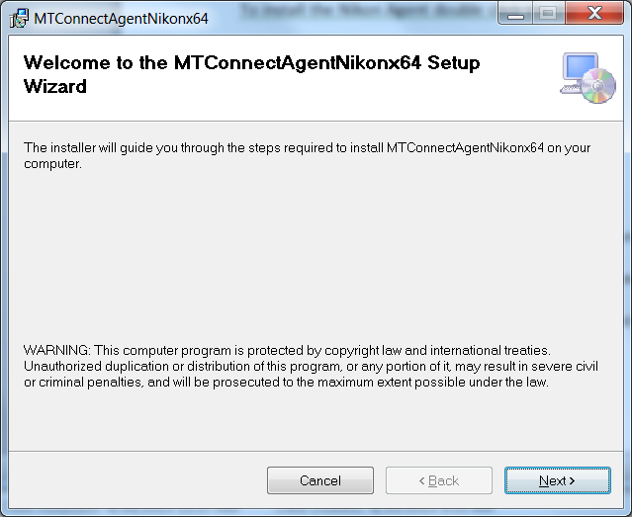

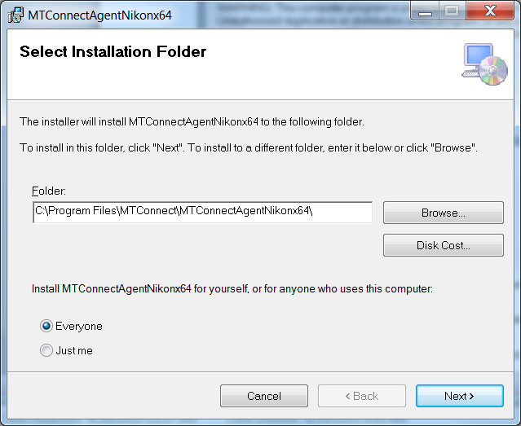

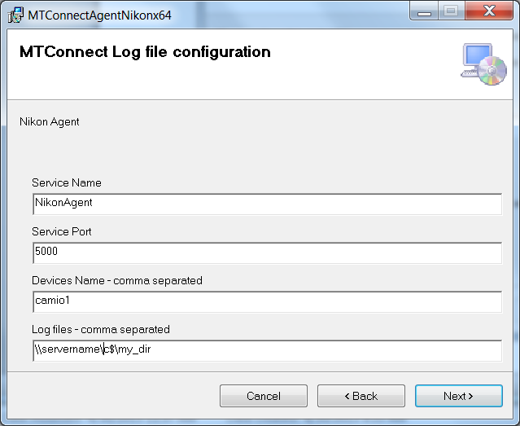

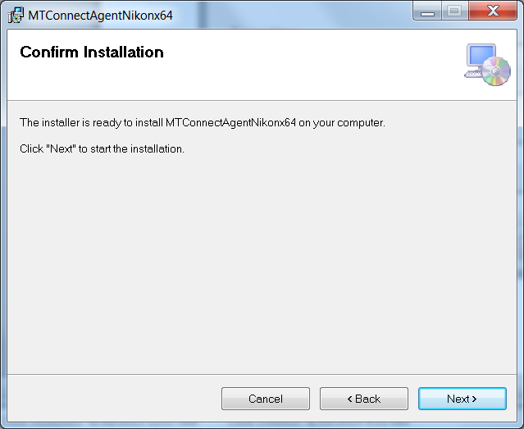

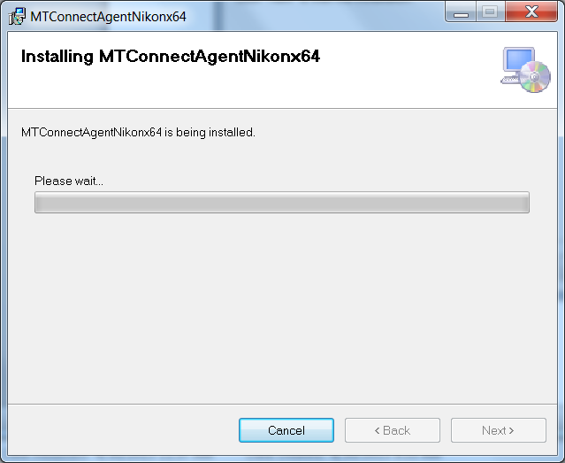

Acknowledge the installation permission challenge, then you should see the installation screen:

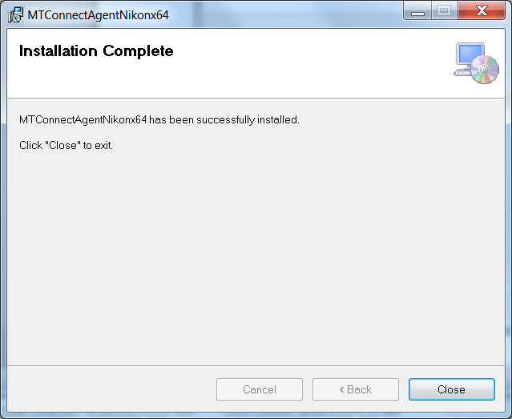

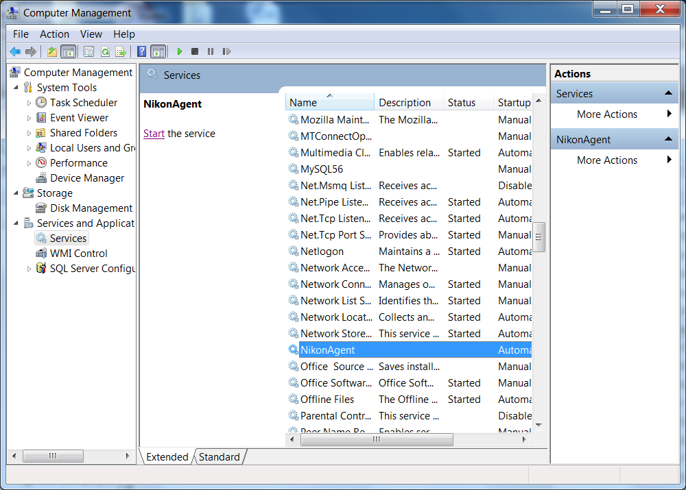

The agent will NOT start unless you tell it to START (unless you reboot).

# Uninstall

First make sure the Nikon Agent is stopped in the Service Control Manager:

Right click on My Computer -> Select Manage -> Acknowledge UAC challenge

Select Services and Applications and then Services, scroll down to NikonAgent, and push Stop button.

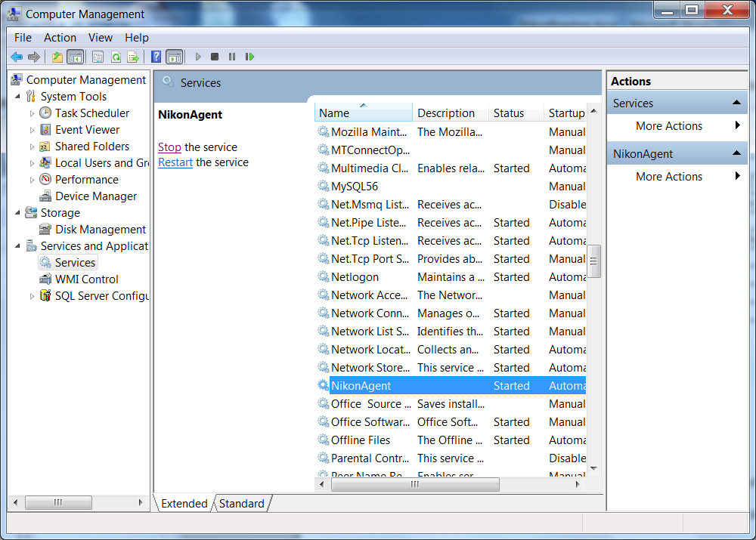

After you have stopped the Nikon Agent service, go into the control panel and uninstall the program: MTConnectAgentNikonx64

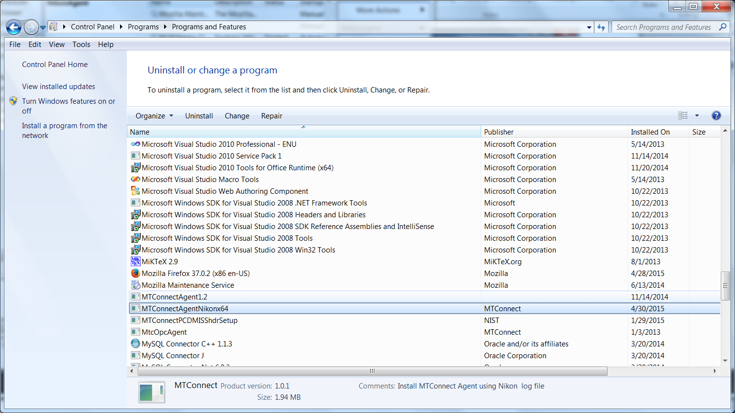

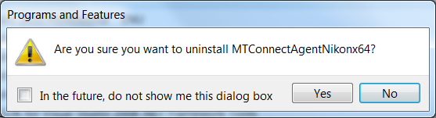

Yes!

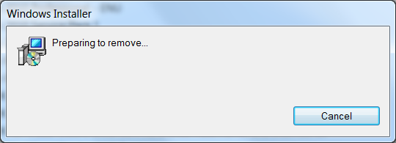

Please wait .. acknowledge UAC permission to uninstall challenge (you must be administrator or have administrator priviledges). It will uninstall and you may see a black console screen popup in the background momemtarily.

And then in the Service Manager click Action->Refresh, and the Nikon Agent service should be removed. The agent code in C:\Program Files\MTConnect\MTConnectAgentNikonx64 should also be removed.

# Configuration

The installation wizard installs the log file Agent into the folder: C:\Program Files\MTConnect\MTConnectAgentNikonx64 where x64 means a 64 bit installation platform, e.g., windows 7. The MTConnect Agent executable must be paired with the correct platform (32 or 64 bit).

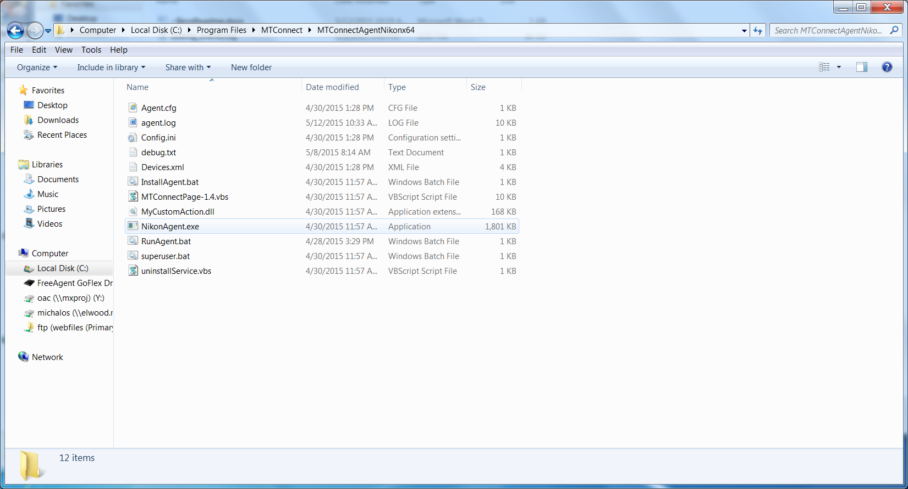

In the folder, the vb script MTConnectPage-1.4.vbs in the can be used to verify that the log file Agent is working. MTConnectPage-1.4.vbs reads the data from the agent via <http://127.0.0.1:5000> and then formats the data. (assuming you have configure the agent port to 5000).